Site Purpose-To sell retail supplies and show events for mountain biking

Target Audience-I tried to do a little bit of research on who likes to mountain bike but I didn’t find a lot. From what I did find though my target audience is mostly men 18 to 40 who love the outdoors.

Site Map

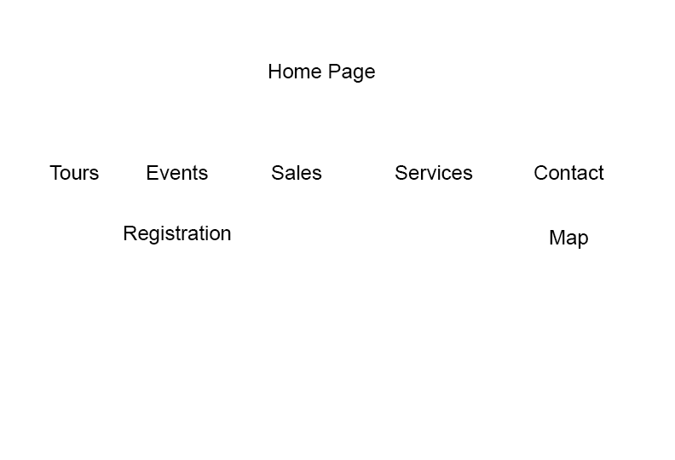

Color Scheme

**Blue:** #3a4660

**Tan:** #c9af98

**Peach:** #ed8a63

**Brown:** #845007

Fonts-Garamond for the headers

Hind or Veranada for paragraphs

Wireframes

Moblil

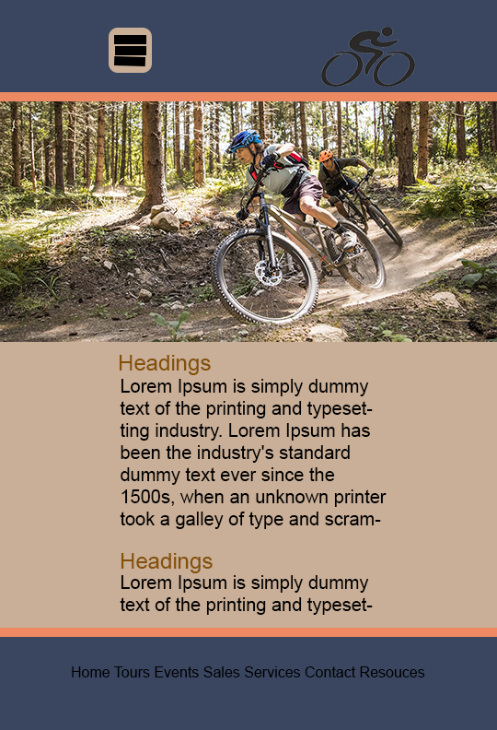

Tablet

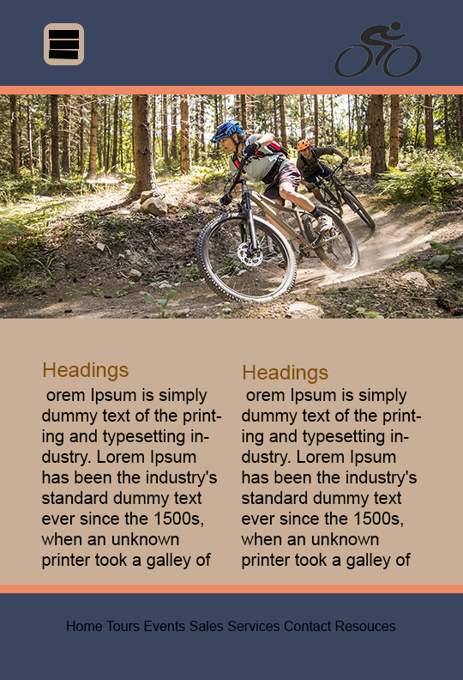

Wide screen

